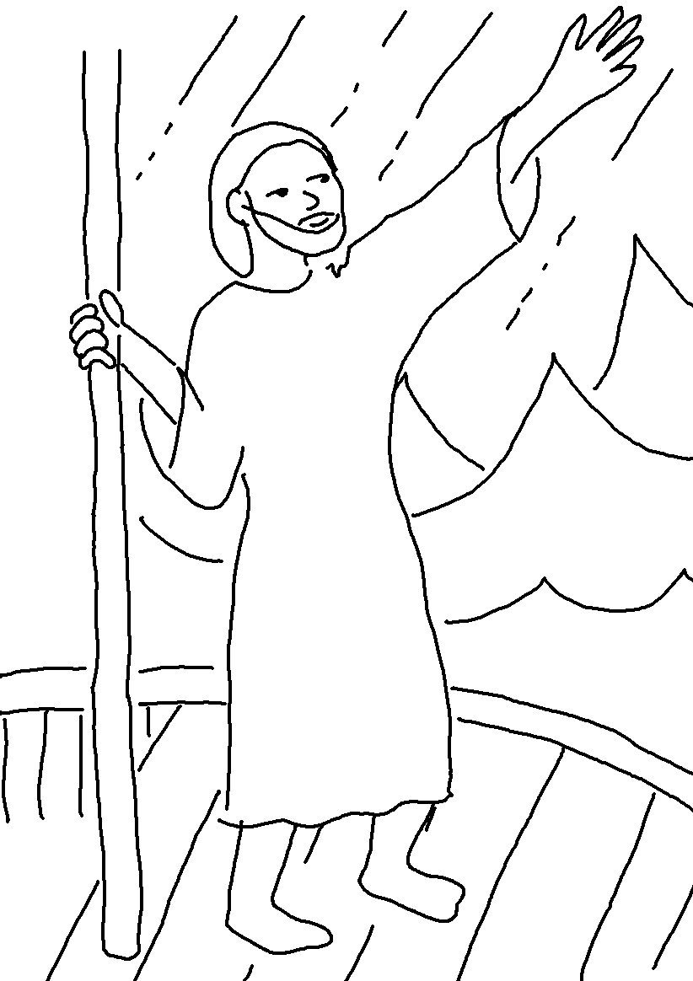

Even the winds and waves obey him!
Matthew 8:27_{NLT}

